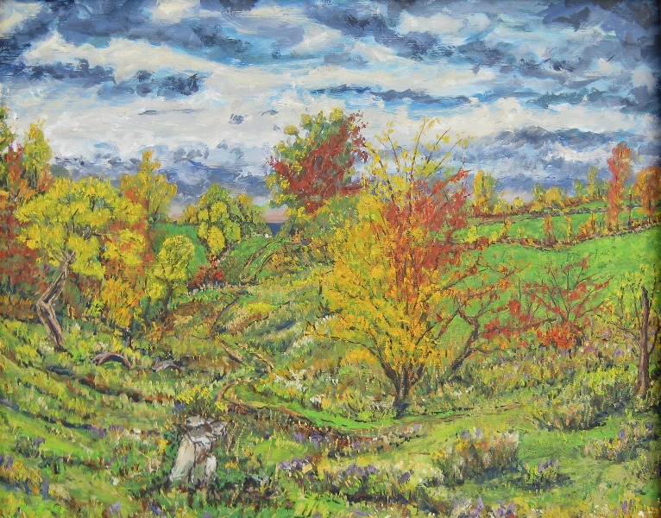
The United Arts Appeal
715 Falconer Street
Jamestown, New York 14701
716-484-7329

November 29, 2010
FOR IMMEDIATE RELEASE

Photo caption: Fredonia artist Thomas Annear received a United Arts Appeal 2010 Projects Pool grant to publicize the December 3-31 “Walking Garden Earth” art exhibit at Westfield’s Patterson Library. The exhibit will feature his work, including “Freeman Farm #1 (Reclaiming the Land - Pigs)” shown here, and that of James Hoggard, Robert John Holland, Tom Malinoski, and Sara Baker Michalak.

UNITED ARTS APPEAL SUPPORTS “WALKING GARDEN EARTH”

Fredonia, NY – The United Arts Appeal of Chautauqua County is supporting an exciting holiday opportunity.

Fredonia artist Thomas Annear received a 2010 Projects Pool grant from the United Arts Appeal to publicize “Walking Garden Earth,” an exhibit featuring his work and that of four other noted local artists, James Hoggard, Robert John Holland, Tom Malinoski, and Sara Baker Michalak.

The public is invited to meet the artists on Friday evening, December 3 from 7 to 9 pm for the exhibit’s opening in the Patterson Library’s Octagon Gallery in Westfield, New York.

The works the artists have selected for this show examine the very notion of “garden.”

Annear’s rich landscapes emerge from his deep commitment to knowing the sources of his family’s food, the land from which his food comes. James Hoggard’s inspiring photographs of nature at its most pure, its most wild, carry us to places of true peace and rejuvenation. Bob Holland observes the natural world and his work describes the processes of building and “unbuilding.” Tom Malinoski’s paintings capture the spiritual essence of natural environments and transport us to places where we can find peace and simply be. Sara Baker Michalak is a natural gardener and artist, and her work expresses her fascination with the beauty of nature that surrounds her. Her “collections” are comprised of objects she has found and enhanced with threads and various markings, and finally arranged to express the dynamic, and personal, relationship between the natural and constructed worlds.

The show will run through Friday, December 31, 2010. The Patterson Library’s Octagon Gallery, at 40 South Portage Street in Westfield, is open Mondays, Tuesdays, and Thursdays from 9 am to 8 pm and Wednesdays, Fridays and Saturdays from 9 am to 5 pm.

For more information about the exhibit, contact Patterson Library or go to the exhibit website at www.WalkingGardenEarth.com.

“Walking Garden Earth” is one of 11 arts projects and individual artists supported this year by the United Arts Appeal’s Projects Pool. The United Arts Appeal is funded through Chautauqua County, local foundations, and generous individuals and businesses. It provides operating support for eight of the larger arts organizations in Chautauqua County: the Chautauqua Regional Youth Ballet, Community Music Project, 1891 Fredonia Opera House, Infinity Performing Arts Program, Jamestown Concert Association, Lucille Ball Little Theatre of Jamestown, Reg Lenna Civic Center, and the Western New York Chamber Orchestra.

For more information about the United Arts Appeal, visit www.UnitedArtsAppeal.org. For information on performances offered by member organizations, visit the United Arts Appeal page on Facebook.

###

