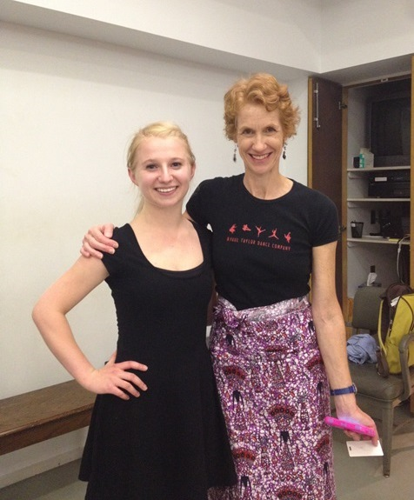

The United Arts Appeal
715 Falconer Street
Jamestown, New York 14701
716-484-7329

News Release
FOR IMMEDIATE RELEASE (March 11, 2015)

Photo caption: The April 15 deadline is fast approaching for organizations and individual artists interested in applying to the 2015 Projects Pool Grants Program of the United Arts Appeal of Chautauqua County. Pictured here is Madeline Jones (left) of Bemus Point, a 2014 award recipient, with Constance Dinapoli, Director of the Paul Taylor Dance Company Summer Intensive at the Peabody Institute in Baltimore, Maryland. Jones’s fellowship helped offset her costs for studying modern dance last August.

United Arts Appeal Grant Deadline Approaching

Jamestown, NY – Organizations and individual artists interested in applying to the 2015 Projects Pool Grants Program of the United Arts Appeal of Chautauqua County (UAA) are reminded that the application deadline is April 15.

Eligible organizations must have non-profit status and may include libraries, municipalities, churches and other community groups.

An artist who has been a Chautauqua County resident for at least one year and works in any artistic discipline, including crafts, choreography, film, fiction, poetry, printmaking, sculpture, painting, video, play writing, performance, music composition and photography, may apply for a Projects Pool Fellowship. Funding priority will be given to those applicants who demonstrate that a fellowship would have significant career impact.

Applications for grants up to $500 are accepted online only and must be received by midnight on Wednesday, April 15, 2015. All applications are screened for eligibility and fulfillment of application requirements. An allocations panel made up of artists and community leaders reviews applications and presents funding recommendations to the United Arts Appeal board for approval.

Artists and community organizations interested in applying for funding through the United Arts Appeal’s Projects Pool Grant Program can obtain application information and funding criteria at the Grants page at www.unitedartsappeal.org.

In addition to funding for individual artists and smaller arts projects through the Projects Pool, the United Arts Appeal provides operating support for eight of the larger arts organizations in Chautauqua County: Chautauqua Regional Youth Ballet, Community Music Project, 1891 Fredonia Opera House, Infinity Visual and Performing Arts, Jamestown Concert Association, Lucille Ball Little Theatre of Jamestown, Reg Lenna Center for The Arts, and the Western New York Chamber Orchestra.

The United Arts Appeal is supported by Chautauqua County, local foundations, corporations, businesses and individuals throughout the county.

For more information about the United Arts Appeal of Chautauqua County, visit www.unitedartsappeal.org. Details of performances offered by each of the member organizations can be found by clicking on their websites on the UAA Members page.

###

