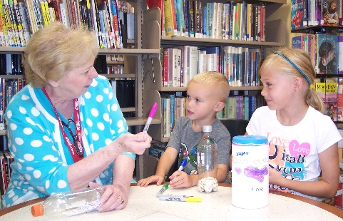

The United Arts Appeal
715 Falconer Street
Jamestown, New York 14701
716-484-7329

News Release
FOR IMMEDIATE RELEASE (January 22, 2015)

Photo caption: The United Arts Appeal has announced its 2015 Projects Pool Grant Program for Chautauqua County organizations and individual artists. With funding received for art supplies for “Color My World: Experiential Learning through the Visual Arts,” making a drum and a shaker were among the many activities children engaged in at the James Prendergast Library last summer.

United Arts Appeal Offering Grants

Jamestown, NY – The United Arts Appeal of Chautauqua County (UAA) has announced its 2015 Projects Pool Grants Program for Chautauqua County artists and organizations.

“Every year a portion of the funds raised through the United Arts Appeal’s fund drive is allocated for individual artists and artistic projects,” said UAA President Lynn Warner. “In 2014, we were pleased to be able to assist three artists and the projects of five organizations, all for the benefit of the cultural life of Chautauqua County.”

Eligible organizations must have non-profit status and may include libraries, municipalities, churches and other community groups.

An artist who has been a Chautauqua County resident for at least one year and works in any artistic discipline, including crafts, dance, film, fiction, poetry, printmaking, sculpture, painting, video, play writing, performance, music composition and photography, may apply for a Projects Pool Fellowship. Awards are based on creative excellence and are to be used for career development.

Grants up to $500 will be awarded.

Grant applications are submitted on-line and must be received by midnight on Wednesday, April 15, 2015. All applications are screened for eligibility and fulfillment of application requirements. An allocations panel made up of Chautauqua County residents who are knowledgeable in the arts reviews applications and presents funding recommendations to the United Arts Appeal board for approval.

Artists and community organizations interesting in applying for funding through the United Arts Appeal’s Projects Pool Grant Program can obtain application information and funding criteria on-line at the Grants page at www.UnitedArtsAppeal.org.

In addition to funding for individual artists and smaller arts projects through the Projects Pool, the United Arts Appeal provides operating support for eight of the larger arts organizations in Chautauqua County: Chautauqua Regional Youth Ballet, Community Music Project, 1891 Fredonia Opera House, Infinity Visual and Performing Arts, Jamestown Concert Association, Lucille Ball Little Theatre of Jamestown, Reg Lenna Center for The Arts, and the Western New York Chamber Orchestra.

The United Arts Appeal is supported by Chautauqua County, local foundations, corporations, businesses and individuals throughout the county.

For more information about the United Arts Appeal of Chautauqua County, with links to each of the member organizations’ websites, visit www.UnitedArtsAppeal.org, the United Arts Appeal page on Facebook, or call (716) 484-7329.

###

