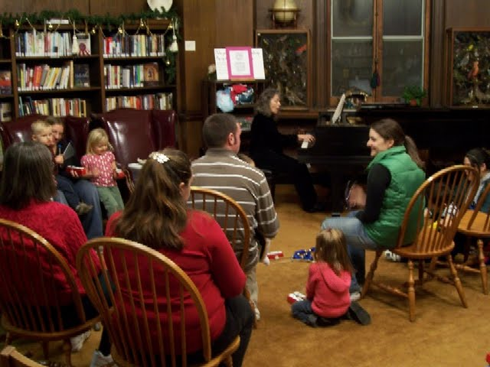

The United Arts Appeal
715 Falconer Street
Jamestown, New York 14701
716-484-7329

News Release
For Immediate Release (February 9, 2012)

Photo caption: The United Arts Appeal is offering grants to Chautauqua County organizations and to individual artists in all disciplines, including photography, fiction, painting, video and more. Applications must be postmarked by March 15, 2012. Previously, Westfield’s Patterson Library received a grant to offer eight weeks of Music Together classes with Kay Barlow, as pictured here.

Arts Grants Offered By United Arts Appeal

Jamestown, NY – The United Arts Appeal of Chautauqua County is accepting applications for its 2012 Projects Pool Grants Program for Chautauqua County artists and organization.

UAA President Rick Davis noted that, “A portion of the funds raised through the United Arts Appeal’s annual campaign will again be allocated for grants for artist career development and artistic projects that benefit the cultural life of Chautauqua County.”

Davis added that grants up to $500 are available to organizations and to individual artists in all disciplines.

Eligible organizations must have non-profit status and may include libraries, municipalities, churches and other community groups.

An artist who has been a Chautauqua County resident for at least one year and works in any artistic discipline, including crafts, choreography, film, fiction, poetry, printmaking, sculpture, painting, video, play writing, performance, music composition and photography, may apply for a Projects Pool Fellowship. Funding priority will be given to those applicants who demonstrate that a fellowship would have significant career impact.

Grant applications are accepted only by mail and must be postmarked by Thursday, March 15, 2012. All applications are screened for eligibility and fulfillment of application requirements. An allocations panel made up of artists and community leaders reviews applications and presents funding recommendations to the United Arts Appeal board for approval.

Artists and community organizations interested in applying for funding through the United Arts Appeal’s Projects Pool can obtain application information and funding criteria on-line at the Grants page at www.unitedartsappeal.org or by contacting the United Arts Appeal at (716) 484-7329 begin_of_the_skype_highlighting.end_of_the_skype_highlighting.

In addition to funding for individual artists and smaller arts projects through the Projects Pool, the United Arts Appeal provides operating support for eight of the larger arts organizations in Chautauqua County: Chautauqua Regional Youth Ballet, Community Music Project, 1891 Fredonia Opera House, Infinity Visual and Performing Arts, Jamestown Concert Association, Lucille Ball Little Theatre of Jamestown, Reg Lenna Civic Center, and the Western New York Chamber Orchestra. For information on performances offered by member organizations, visit the United Arts Appeal page on Facebook.

The United Arts Appeal is supported by Chautauqua County, local foundations, corporations, businesses and individuals throughout the county.

For more information about the United Arts Appeal of Chautauqua County, visit www.unitedartsappeal.org.

###

