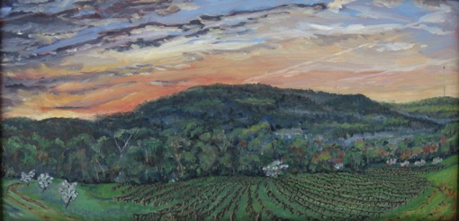

The United Arts Appeal
715 Falconer Street
Jamestown, New York 14701
716-484-7329

August 10, 2010
FOR IMMEDIATE RELEASE

Photo caption: Fredonia artist Thomas Annear received a United Arts Appeal 2010 Projects Pool grant to publicize the December 3-31 “Walking Garden Earth” art exhibit at Westfield’s Patterson Library. The exhibit will feature his work, including “Water St Vineyard #3” shown here, and that of four other regional artists.

UNITED ARTS APPEAL ANNOUNCES GRANT WINNERS

Jamestown, NY –The United Arts Appeal has announced the recipients of its 2010 Projects Pool grants to Chautauqua County non-profit organizations and individual artists.

In making the announcement, UAA President Rick Davis noted, “Each year, the United Arts Appeal awards grants for career development and artistic projects that benefit the cultural life of Chautauqua County. We were delighted to receive a significant number of applications this year, representing a wonderful group of projects.”

After being screened for eligibility and fulfillment of requirements, applications were reviewed by an allocations panel made up of artists and community leaders. Their recommendations were then approved by the United Arts Appeal board.

The United Arts Appeal 2010 fellowships and grants are being awarded to:

Individuals:
- Thomas Annear, Fredonia: publicity materials for Walking Garden Earth
- Jenny Brown, Lakewood: photo printer
- Ralph Pisano, Jamestown: portrait framing
- Albert Sorci, Fredonia: staging The Little Yellow House

Organizations:
- Access to the Arts, Dunkirk: Universal Drum & Dance Workshop
- Aspire of WNY, Lakewood: “Turnaround” community art project
- Dunkirk Historical Society, Dunkirk: 2010-2011 Folk Arts Program
- James Prendergast Library, Jamestown: Storytelling by Karima Amin and Paul Leone
- North Shore Arts Alliance, Fredonia: Publicity Support for NSAA Events
- Patterson Library, Westfield: Music Together at Patterson Library
- Villenova Grange #604, Villenova: Community Painted Quilt Squares

In addition to funding for individual artists and smaller arts projects through the Projects Pool, the United Arts Appeal provides operating support for eight of the larger arts organizations in Chautauqua County. These include the Chautauqua Regional Youth Ballet, Community Music Project, 1891 Fredonia Opera House, Infinity Performing Arts Program, Jamestown Concert Association, Lucille Ball Little Theatre of Jamestown, Reg Lenna Civic Center, and the Western New York Chamber Orchestra.

The United Arts Appeal is supported by Chautauqua County, local foundations, corporations, businesses and individuals throughout the county. For more information, visit www.UnitedArtsAppeal.org.

###

