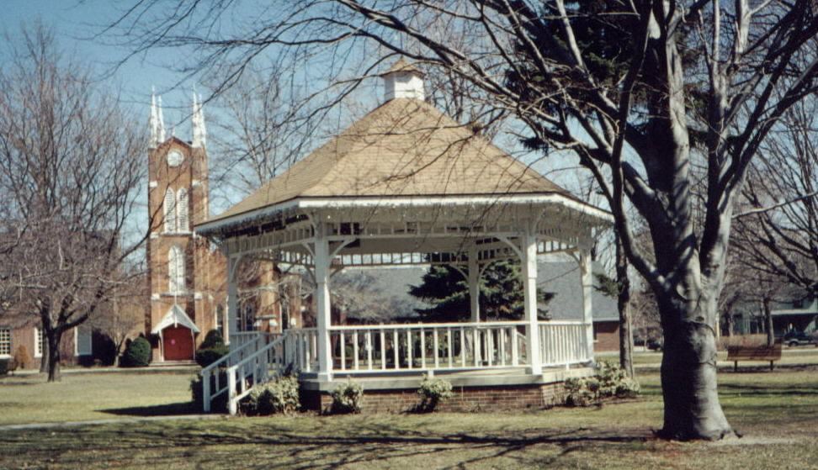

The United Arts Appeal
715 Falconer Street
Jamestown, New York 14701
716-484-7329

News Release
FOR IMMEDIATE RELEASE (January 24, 2014)

Photo caption: The United Arts Appeal has announced its 2014 Projects Pool Grant Program for Chautauqua County organizations and individual artists. In 2013, the Village of Westfield Recreation Department received a grant for the free summer concert series in the beautiful gazebo in Moore Park.

Grants Offered by United Arts Appeal

Jamestown, NY – The United Arts Appeal of Chautauqua County has announced its 2014 Projects Pool Grants Program for Chautauqua County artists and organizations.

“Every year a portion of the funds raised through the United Arts Appeal’s fund drive is allocated for individual artists and artistic projects,” said UAA President Rick Davis. “This past year we were pleased to be able to assist four artists and the projects of seven organizations, all for the benefit of the cultural life of Chautauqua County.”

Eligible organizations must have non-profit status and may include libraries, municipalities, churches and other community groups.

An artist who has been a Chautauqua County resident for at least one year and works in any artistic discipline, including crafts, choreography, film, fiction, poetry, printmaking, sculpture, painting, video, play writing, performance, music composition and photography, may apply for a Projects Pool Fellowship. Awards are based on creative excellence and are to be used for career development.

Grants up to $500 will be awarded.

Grant applications are submitted on-line and must be received by midnight on Tuesday, April 15, 2014. All applications are screened for eligibility and fulfillment of application requirements. An allocations panel made up of Chautauqua County residents who are knowledgeable in the arts reviews applications and presents funding recommendations to the United Arts Appeal board for approval.

Artists and community organizations interested in applying for funding through the United Arts Appeal’s Projects Pool Grant Program can obtain application information and funding criteria on-line at the Grants page at www.unitedartsappeal.org. begin_of_the_skype_highlighting.end_of_the_skype_highlighting

In addition to funding for individual artists and smaller arts projects through the Projects Pool, the United Arts Appeal provides operating support for eight of the larger arts organizations in Chautauqua County: Chautauqua Regional Youth Ballet, Community Music Project, 1891 Fredonia Opera House, Infinity Visual and Performing Arts, Jamestown Concert Association, Lucille Ball Little Theatre of Jamestown, Reg Lenna Center for the Arts, and the Western New York Chamber Orchestra.

All these organizations will be giving presentations at Kaleidoscope, a collaborative variety show at the Lucille Ball Little Theatre of Jamestown at 2 p.m. on Sunday, March 2, and at the Fredonia Opera House at 2 p.m. on Sunday, March 9. Performances will include folk music, singer/songwriters, ballet, theater, chamber players and singers, and more.

The United Arts Appeal is supported by Chautauqua County, local foundations, corporations, businesses and individuals throughout the county.

For more information about the United Arts Appeal of Chautauqua County, with links to each of the member organizations’ websites, visit www.unitedartsappeal.org or call (716) 484-7329.

###

