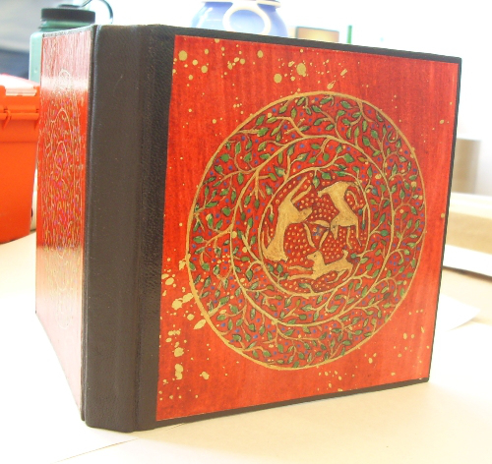

The United Arts Appeal
715 Falconer Street
Jamestown, New York 14701
716-484-7329

News Release
FOR IMMEDIATE RELEASE (March 14, 2014)

Photo caption: April 15 is the deadline for applications to the 2014 Projects Pool Grant Program of the United Arts Appeal of Chautauqua County. Grants up to $500 will be awarded to both organizations and individual artists in varied disciplines. Pictured here is Debra Eck’s hand painted lacquer style book, one of her projects at the 2013 Paper Book Intensive, a highly competitive working sabbatical for paper and book practitioners from all over the world. Eck’s participation in this workshop, held at Ox-Bow in Michigan, was assisted by a Projects Pool grant.

April 15 is United Arts Appeal Grant Deadline

Jamestown, NY – The United Arts Appeal of Chautauqua County is accepting applications to its 2014 Projects Pool Grant Program through April 15.

Grants up to $500 are available to organizations and to individual artists in all disciplines.

Eligible organizations must have non-profit status and may include libraries, municipalities, churches and other community groups.

An artist who has been a Chautauqua County resident for at least one year and works in any artistic discipline, including crafts, choreography, film, fiction, poetry, printmaking, sculpture, painting, video, play writing, performance, music composition and photography, may apply for a Projects Pool Fellowship. Funding priority will be given to those applicants who demonstrate that a fellowship would have significant career impact.

Grant applications are accepted only online and must be received by midnight on Tuesday, April 15, 2014. All applications are screened for eligibility and fulfillment of application requirements. An allocations panel made up of artists and community leaders reviews applications and presents funding recommendations to the United Arts Appeal board for approval.

Artists and community organizations interested in applying for funding through the United Arts Appeal’s Projects Pool Grant Program can obtain application information and funding criteria at the Grants page at www.unitedartsappeal.org.

In addition to funding for individual artists and smaller arts projects through the Projects Pool, the United Arts Appeal provides operating support for eight of the larger arts organizations in Chautauqua County: Chautauqua Regional Youth Ballet, Community Music Project, 1891 Fredonia Opera House, Infinity Visual and Performing Arts, Jamestown Concert Association, Lucille Ball Little Theatre of Jamestown, Reg Lenna Center for the Arts, and the Western New York Chamber Orchestra.

The United Arts Appeal is supported by Chautauqua County, local foundations, corporations, businesses and individuals throughout the county.

For more information about the United Arts Appeal of Chautauqua County, visit www.unitedartsappeal.org. Details of performances offered by each of the member organizations can be found by clicking on their websites on the UAA Members page.

###

