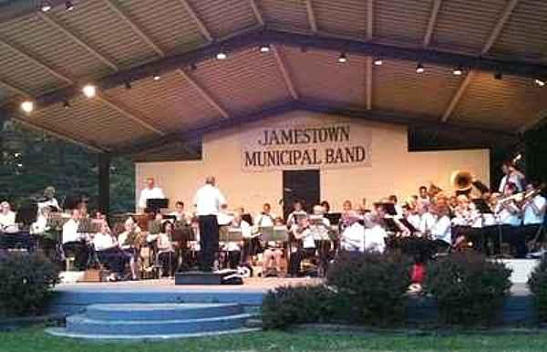

The United Arts Appeal
715 Falconer Street
Jamestown, New York 14701
716-484-7329

News Release
FOR IMMEDIATE RELEASE (May 8, 2013)

Photo caption: The City of Jamestown Department of Parks, Recreation and Conservation has been awarded a 2013 United Arts Appeal of Chautauqua County Projects Pool Grant to support its 2013 Summer Bandshell Concert Series. A total of 11 grants were awarded to local non-profit organizations and individual artists.

2013 United Arts Appeal Grant Winners Announced

Jamestown, NY –The United Arts Appeal of Chautauqua County has announced the recipients of its 2013 Projects Pool Grant Program awards to local organizations and individual artists.

When making the announcement, UAA President Rick Davis observed, “The United Arts Appeal awards grants for career development and artistic projects that benefit the cultural life of Chautauqua County. We received a significant number of quality applications this year and are pleased to be able to support these worthwhile projects.”

Eligible organizations must have non-profit status and individuals must have been Chautauqua County residents for at least one year and work in any artistic discipline. After being screened for eligibility and fulfillment of requirements, applications are reviewed by an allocations panel made up of artists and community leaders. Their recommendations are then approved by the United Arts Appeal board.

The United Arts Appeal 2013 fellowships and grants are being awarded to:

Individual Artists:
- Debra Eck: Paper Book Intensive
- Eric Johnson: Figurative Painting
- Joanne Merrick Johnson: Figurative Yard Sculptures
- Valerie Walawender: Miniature Models

Organizations:
- Boys and Girls Club of Northern Chautauqua County: Folk Arts
- Chautauqua Regional Youth Symphony: Guests Artists Support
- Great Lake FX: New York State of Mind
- Jamestown Department of Parks, Recreation and Conservation: 2013 Summer Bandshell Concert Series
- Patterson Library: Music Together at Patterson Library
- Resource Center: Labyrinth Totems
- Village of Westfield Recreation Department: Concerts in Moore Park Series

In addition to funding for individual artists and smaller arts projects through the Projects Pool Grant Program, the United Arts Appeal provides operating support for eight of the larger arts organizations in Chautauqua County. These include the Chautauqua Regional Youth Ballet, Community Music Project, 1891 Fredonia Opera House, Infinity Visual and Performing Arts, Jamestown Concert Association, Lucille Ball Little Theatre of Jamestown, Reg Lenna Civic Center, and the Western New York Chamber Orchestra.

The United Arts Appeal is supported by Chautauqua County, local foundations, corporations, businesses and individuals throughout the county. For more information, visit www.UnitedArtsAppeal.org.

For information on performances offered by member organizations, click on visit the Opportunities page on the website or the United Arts Appeal page on Facebook.

###

