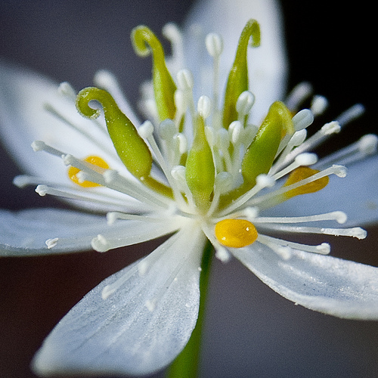

The United Arts Appeal
715 Falconer Street
Jamestown, New York 14701
716-484-7329

April 20, 2011
FOR IMMEDIATE RELEASE

Photo caption: One of 15 award recipients in 2011, Jamestown photographer Jennifer Schlick received a United Arts Appeal Projects Pool grant to present her Wildflowers exhibit at the James Prendergast Library gallery in May. Her “Goldthread” is shown here.

UNITED ARTS APPEAL ANNOUNCES 2011 GRANT WINNERS

Jamestown, NY –The United Arts Appeal has announced the recipients of its 2011 Projects Pool grants to Chautauqua County non-profit organizations and individual artists.

When making the announcement, UAA President Rick Davis observed, “The United Arts Appeal awards grants for career development and artistic projects that benefit the cultural life of Chautauqua County. We received a significant number of quality applications this year and are pleased to be able to support these worthwhile projects.”

After being screened for eligibility and fulfillment of requirements, applications were reviewed by an allocations panel made up of artists and community leaders. Their recommendations were then approved by the United Arts Appeal board.

The United Arts Appeal 2011 fellowships and grants are being awarded to:

Individual Artists:
- Brittany Bush, Jamestown: New York City dance program
- Casey R. Gray, Fredonia: organ recital and children’s workshop
- James Hoggard, Fredonia: framing for gallery shows
- Joyce Ronan Rose, Lakewood: expand weaving classes
- Jennifer Schlick, Jamestown: Prendergast wildflower photography exhibit

Organizations:
- Chautauqua Regional Youth Symphony: Meet the Composer
- Eastside Family YMCA: Clean Streets Project
- Fenton History Center: Spoon River Project
- James Prendergast Library: Musical Program for Families by Dave Ruch
- Jamestown Audubon Society: Art in the Wild
- Jamestown Juneteenth Planning Committee: Gospel Fest
- North Shore Arts Alliance: Publicity Support for NSAA Events
- Patterson Library: Music Together at Patterson Library
- The Resource Center: Riverwalk Community Labyrinth Project
- Villenova Grange #604: Community Painted Quilt Squares Out & About

In addition to funding for individual artists and smaller arts projects through the Projects Pool, the United Arts Appeal provides operating support for eight of the larger arts organizations in Chautauqua County. These include the Chautauqua Regional Youth Ballet, Community Music Project, 1891 Fredonia Opera House, Infinity Visual and Performing Arts, Jamestown Concert Association, Lucille Ball Little Theatre of Jamestown, Reg Lenna Civic Center, and the Western New York Chamber Orchestra.

The United Arts Appeal is supported by Chautauqua County, local foundations, corporations, businesses and individuals throughout the county. For more information on the United Arts Appeal, visit www.UnitedArtsAppeal.org. For information on performances offered by member organizations, visit the United Arts Appeal page on Facebook.

###

