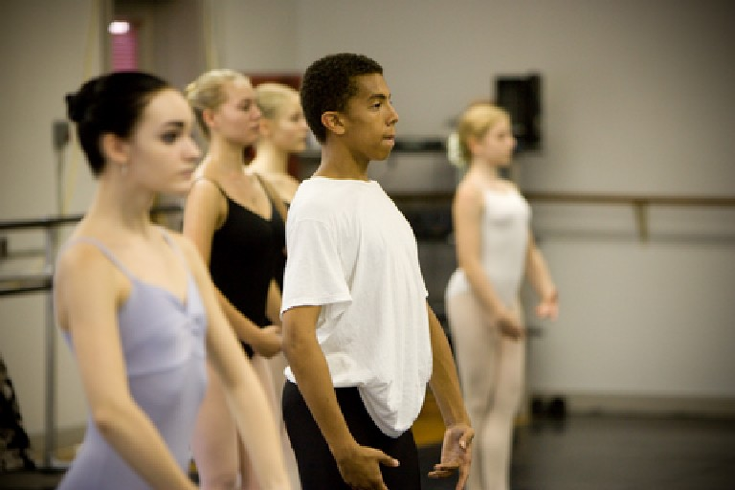
The United Arts Appeal
715 Falconer Street
Jamestown, New York 14701
716-484-7329

June 11, 2010
FOR IMMEDIATE RELEASE

Photo caption: With funding from the Chautauqua Region Community Foundation, the United Arts Appeal of Chautauqua County recently launched its new website at www.UnitedArtsAppeal.org. On the site’s Funding page, Chautauqua County artists and non-profit community organizations can find grant application forms that must be postmarked by June 30.

UNITED ARTS APPEAL THANKS CRCF FOR NEW WEBSITE

Jamestown, NY – The United Arts Appeal of Chautauqua County expresses appreciation to the Chautauqua Region Community Foundation for its recently launched new website.

UAA Treasurer Sally Ulrich stated, “The member organizations of the United Arts Appeal are thrilled with our beautiful new website that was made possible by funding from the Chautauqua Region Community Foundation! Now the community can easily see some of the range of arts programming and scope of its support in Chautauqua County.”

The site, at www.UnitedArtsAppeal.org, highlights the work of the United Arts Appeal’s member organizations and offers links to each of their websites. These include the Chautauqua Regional Youth Ballet, Community Music Project, 1891 Fredonia Opera House, Infinity Performing Arts Program, Jamestown Concert Association, Lucille Ball Little Theatre of Jamestown, Reg Lenna Civic Center, and the Western New York Chamber Orchestra.

Other web pages list the benefits of supporting the arts, describe how individuals and businesses can do so, and give a BRAVO! to contributors.

Also accessible at www.UnitedArtsAppeal.com, the site was designed by Sue Kellogg of Kellogg Design in Lakewood.

On the site’s Funding page, Chautauqua County artists and non-profit community organizations can find funding criteria and application forms for grants of up to $500 that will be awarded through the United Arts Appeal Projects Pool. Applications must be postmarked by June 30.

The United Arts Appeal is supported by Chautauqua County, local foundations, corporations, businesses and individuals throughout the county.

###

