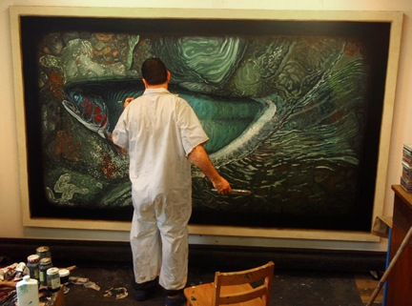
The United Arts Appeal
715 Falconer Street
Jamestown, New York 14701
716-484-7329

November 2, 2010
FOR IMMEDIATE RELEASE

Photo caption: Painter Alberto Rey is one of 22 artists who will open their studios to the public on Saturday, November 13, for the North Shore Arts Alliance’s Chautauqua-Lake Erie Art Trail, sponsored in part by the United Arts Appeal of Chautauqua County.

UNITED ARTS APPEAL SUPPORTS CHAUTAUQUA-LAKE ERIE ART TRAIL

Jamestown, NY – “We’re excited that one of the wonderful projects supported by the United Arts Appeal is free to the public and just in time for the holidays!”

That’s how United Arts Appeal of Chautauqua County president Rick Davis described the North Shore Arts Alliance’s signature event, the Chautauqua-Lake Erie Art Trail (CLEAT), scheduled for Saturday, November 13.

Extending from Silver Creek to Westfield along the Lake Erie shoreline and including artists’ studios in Chautauqua Institution, Hartfield, Forestville, South Dayton and more, the November Art Trail offers the public an opportunity to visit the studios of northern Chautauqua County’s leading artists.

Between 10 a.m. to 5 p.m., visitors can observe 22 participating artists -- professional sculptors, photographers, ceramicists, painters, jewelers, wood turners, stained glass and other mixed media artists – working in their studios. Hands-on demonstrations include opportunities for visitors to make their own hand-pulled prints and to manipulate photo film.

Just in time for the holidays, one-of-a-kind art work will also be available for sale.

The North Shore Arts Alliance was founded in 2008 as a co-operative marketing and promotional effort on behalf of 25 professional working artists. It has a juried regional membership and works to create and enhance year-round opportunities for the arts in western New York, especially opportunities to show work.

The Chautauqua-Lake Erie Art Trail is a free, family-friendly event. A Google map of the studio tour locations, a downloadable printer-friendly version of the brochure, and information about all the participating artists can be found at www.ChautauquaArtTrail.com. You can also find us on Facebook. For additional information or to request a brochure, call Thomas Annear at (716) 679-9254.

The Chautauqua-Lake Erie Art Trail is one of 11 arts projects and individual artists supported this year by the United Arts Appeal’s Projects Pool. The United Arts Appeal is funded through Chautauqua County, local foundations, and generous individuals and businesses. It provides operating support for eight of the larger arts organizations in Chautauqua County: the Chautauqua Regional Youth Ballet, Community Music Project, 1891 Fredonia Opera House, Infinity Performing Arts Program, Jamestown Concert Association, Lucille Ball Little Theatre of Jamestown, Reg Lenna Civic Center, and the Western New York Chamber Orchestra.

For more information about the United Arts Appeal, visit www.UnitedArtsAppeal.org. For information on performances offered by member organizations, visit the United Arts Appeal page on Facebook.

###

