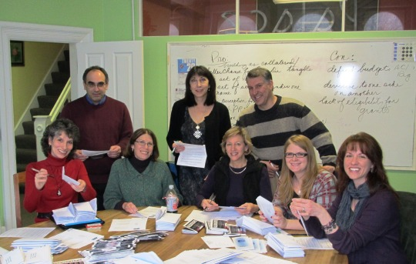

The United Arts Appeal
715 Falconer Street
Jamestown, New York 14701
716-484-7329

News Release
FOR IMMEDIATE RELEASE (January 23, 2012)

Photo caption: United Arts Appeal of Chautauqua County board members recently sent letters to local businesses and selected individuals, requesting their support for the arts in 2012. Included was an invitation to “Kaleidoscope,” a sampling of the offerings of the eight UAA member organizations that will be presented on Friday, February 3 at the Fredonia Opera House and Friday, February 17 in Jamestown’s Reg Lenna Civic Center. Pictured here are (standing, from left) Dan Pierce, Elizabeth Bush, Rick Davis, (seated, from left) Julie Newell, Lissa VanDewark, Sally Ulrich, Stephanie Rogers, and Shane Hawkins.

“Kaleidoscope” To Launch United Arts Appeal 2012 Fund Drive

Jamestown, NY – The United Arts Appeal of Chautauqua County is creating a special event to launch its 2012 fund drive.

“Kaleidoscope” will be presented on Friday, February 3 at the Fredonia Opera House and again on Friday, February 17 at Jamestown’s Reg Lenna Civic Center. Beginning at 7 pm and emceed by Jamestown’s comedy improv troupe, The Unexpected Guests, both evenings will feature samplings of performances including folk music, ballet, theater, chamber players and singers.

All eight UAA member organizations -- the Chautauqua Regional Youth Ballet, Community Music Project, 1891 Fredonia Opera House, Infinity Visual & Performing Arts, Jamestown Concert Association, Lucille Ball Little Theatre of Jamestown, Reg Lenna Civic Center, and the Western New York Chamber Orchestra -- will contribute to the delightful evening!

“This year we are presenting ‘Kaleidoscope’ to give the entire community the opportunity to see the great arts offerings in Chautauqua County,” said Rick Davis, UAA board president.

In addition, door prizes of free tickets to presentations by all the member organizations will be given away each evening.

Admission for either performance is only $5. Tickets for the February 3 performance in Fredonia can be reserved by calling (716) 679-1891 and for February 17 in Jamestown by calling (716) 484-7070. Tickets will also be available at the door.

UAA board members recently sent letters to businesses and selected individuals throughout the county. The letters included an invitation to “Kaleidoscope” and asked for support for UAA members and the many smaller groups and independent artists that receive UAA funding.

“This is the only request we make of the local community,” Davis noted. “Our focus is on soliciting businesses because of the strong impact a healthy arts community has on the local economy. We are also deeply grateful for funding from the county, local foundations, and individuals.”

In 2011 the United Arts Appeal received major support from Chautauqua County, the Jessie Smith Darrah Fund, the Hultquist Foundation, and the Reg and Betty Lenna Fund. Patrons (contributors of $1,000+) for the 2011 Fund Drive were the Community Development Association, Lyndon and Melanie Gritters, and Matric Limited. M. L. Feather, KeyBank, Phillips Lytle LLP, Dr. Bruce Rockwell and Wegmans made Special Gifts ($500+), and Donors ($250+) included Carlson’s Jewelry, Fessenden Laumer & DeAngelo, Margaret S. and F. John Fuchs, Mark and Donna Hampton, Jamestown Area Medical Associates LLP, Lake Shore Savings Bank, Betsy and David Shepherd, Short & Smith Insurance Associates, Tyler Swanson and Carolyn French, Lissa and Sherwood VanDewark, and the Gebbie Foundation/Director’s Discretionary Grant on behalf of Rhoe Henderson.

Contributions to the United Arts Appeal are tax deductible, and contributors are offered a range of benefits for their generosity, including free admissions to selected performances and recognition in printed programs and on the UAA’s website.

Any business or individual that did not receive a request for support is invited to call (716) 484-7329 and ask for materials.

For more information, visit http://unitedartsappeal.org/.

For information on performances offered by member organizations, visit the United Arts Appeal page on Facebook.

###

