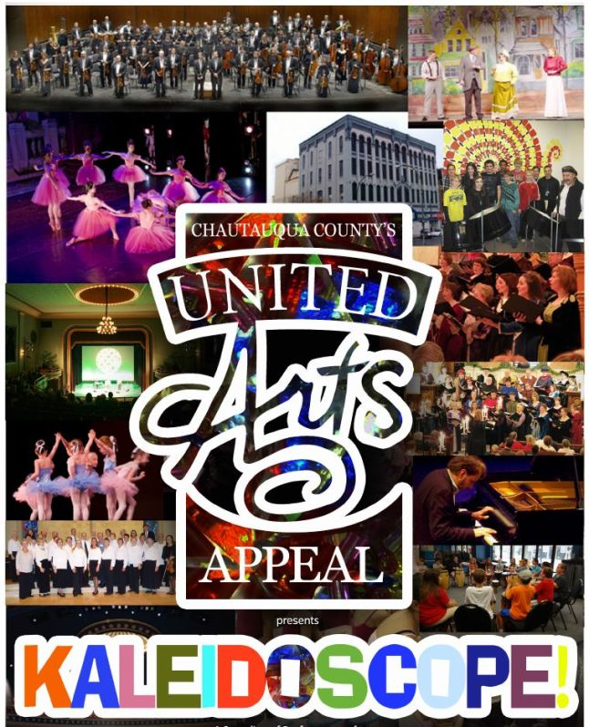

The United Arts Appeal
715 Falconer Street
Jamestown, New York 14701
716-484-7329

News Release
FOR IMMEDIATE RELEASE (February 18, 2014)

Photo caption: The United Arts Appeal of Chautauqua County is presenting Kaleidoscope!, a special variety program showcasing some of the many great arts opportunities in Chautauqua County. Performances will be at 2 p.m. on Sunday, March 2, at the Lucille Ball Little Theatre of Jamestown and again on Sunday, March 9, at 2 p.m. at the 1891 Fredonia Opera House.

United Arts Appeal Presenting Kaleidoscope! First Sundays in March

Jamestown, NY – “The United Arts Appeal of Chautauqua County will celebrate the arts in a collaborative way in March, when it presents Kaleidoscope!, a special variety program showcasing some of the many great arts opportunities in our county.”

That’s how United Arts Appeal President Rick Davis described the UAA’s productions scheduled for 2 p.m. on Sunday, March 2, at the Lucille Ball Little Theatre of Jamestown and again on Sunday, March 9, at 2 p.m. at the 1891 Fredonia Opera House.

“The UAA first presented Kaleidoscope! two years ago,” Davis said. “We look forward to inspiring folks once more with some of the local offerings that add so much to the quality of life in Chautauqua County.”

All eight UAA members will contribute to Kaleidoscope!

On the program will be solo and trio performances by the Chautauqua Regional Youth Ballet, Renaissance-costumed Chautauqua Chamber Singers from Community Music Project, selections from the 1891 Fredonia Opera House’s Folk Series and Bach Festival, Infinity Visual and Performing Arts duo SYMBA, a scene from a Lucille Ball Little Theatre of Jamestown’s upcoming Plaza Suite, Reg Lenna Center for the Arts’ Rolling Hills Radio producer/host Ken Hardley, excerpts from the Western New York Chamber Orchestra’s March 30 presentation of Johann Strauss’s Die Fledermaus, and more.

Admission is $10. Tickets for the Sunday, March 2, Kaleidoscope! can be purchased at the Lucille Ball Little Theatre and by calling (716) 483-1095. Those for the Sunday, March 9, show at the 1891 Fredonia Opera House can be reserved by calling (716) 679-1891. Tickets for both performances will also be available at the door.

Door prizes of free tickets to member organizations’ presentations will be given away at both events.

In addition to funding for individual artists and smaller arts projects through its Projects Pool, the United Arts Appeal provides operating support for eight of the larger arts organizations in Chautauqua County: Chautauqua Regional Youth Ballet, Community Music Project, 1891 Fredonia Opera House, Infinity Visual and Performing Arts, Jamestown Concert Association, Lucille Ball Little Theatre of Jamestown, Reg Lenna Center for the Arts, and Western New York Chamber Orchestra.

Businesses and individuals that would like to support the arts in Chautauqua County are invited to send their tax-deductible contributions to the United Arts Appeal, 715 Falconer Street, Jamestown, NY 14701.

For more information, visit UnitedArtsAppeal.org and the United Arts Appeal page on Facebook.

###

