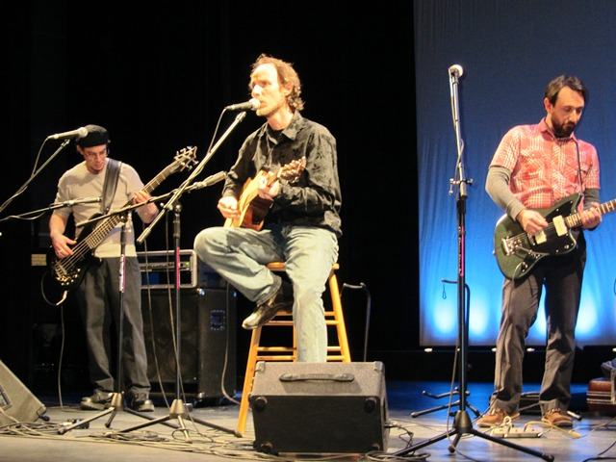

The United Arts Appeal
715 Falconer Street
Jamestown, New York 14701
716-484-7329

News Release
For Immediate Release (February 8, 2012)

Photo caption: Representing Jamestown’s Reg Lenna Civic Center, (from left) Facilities Support Jay Peterson, Facilities Director Jeff Erickson and Board President Nate Arnone will perform at the United Arts Appeal’s “Kaleidoscope” at the Reg on Friday, February 17 at 7 pm.

United Arts Appeal’s “Kaleidoscope” in Jamestown February 17

Jamestown, NY – After a delightful presentation last Friday (February 3) in Fredonia, the United Arts Appeal of Chautauqua County is offering “Kaleidoscope” in Jamestown on Friday, February 17.

“We’re so pleased with all the terrific performances,” noted UAA board member Sally Ulrich, “that we’re really looking forward to our Jamestown event. We can’t think of a better way to let the community know about all our wonderful arts offerings!”

The 7 pm presentation at the Reg Lenna Civic Center will be emceed by Jamestown’s own comedy improv troupe, The Unexpected Guests, and will feature folk music, ballet, theater, chamber singers and players, and more.

In addition to funding for individual artists and smaller arts projects through its Projects Pool, the United Arts Appeal provides operating support for eight of the larger arts organizations in Chautauqua County.

All eight UAA member organizations -- the Chautauqua Regional Youth Ballet, Community Music Project, 1891 Fredonia Opera House, Infinity Visual & Performing Arts, Jamestown Concert Association, Lucille Ball Little Theatre of Jamestown, Reg Lenna Civic Center, and the Western New York Chamber Orchestra -- will contribute to “Kaleidoscope.”

Door prizes of free tickets to presentations by the member organizations will be given away throughout the evening.

Admission is only $5. Tickets can be reserved by calling (716) 484-7070 and will also be available at the door.

For more information, visit http://unitedartsappeal.org/.

For information on performances offered by member organizations, visit the United Arts Appeal page on Facebook.

###

