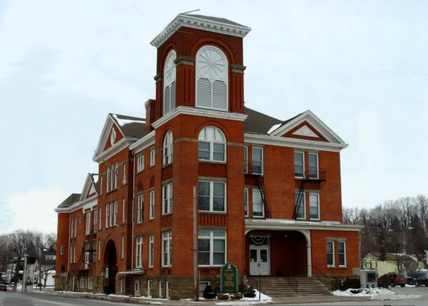

The United Arts Appeal
715 Falconer Street
Jamestown, New York 14701
716-484-7329

News Release
For Immediate Release (January 27, 2012)

Photo caption: In recognition of the contribution of the arts to the economic and social well-being of the community, Mayor Stephen W. Keefe is proclaiming Friday, February 3, 2012, as United Arts Appeal Day in the Village of Fredonia. That evening “Kaleidoscope,” a sampling of the offerings of the eight UAA member organizations, will be presented at the Fredonia Opera House. The 1891 Opera House shares a building with the Village Hall, pictured here.

Fredonia Mayor Keefe Proclaims February 3 “UAA Day”

Jamestown, NY – Several factors contributed to Mayor Stephen W. Keefe’s decision to recognize the United Arts Appeal of Chautauqua County and proclaim Friday, February 3 as “UAA Day” in the Village of Fredonia.

As his proclamation notes, local arts organizations are important because they help weave art and culture into the fabric of our daily life, enriching our lives and improving the economic health of our community. The United Arts Appeal (UAA) is a non-profit organization that funds the arts within Chautauqua County and promotes community development and revitalization. Two of the UAA’s eight member arts organizations are the 1891 Fredonia Opera House and the Western New York Chamber Orchestra, both of which operate within Fredonia.

The special event that inspired Mayor Keefe’s proclamation is the UAA’s kick-off of its 2012 fund drive with Kaleidoscope!, a show featuring samplings of performances by all eight member organizations at the 1891 Fredonia Opera House at 7 pm on Friday, February 3.

Presentations in this variety-style show will include the Opera House’s offering of folk singers/songwriters and Celtic harpist Kent and Nannette Knappenberger, excerpts from the Chautauqua Regional Youth Ballet’s The Nutcracker, the Western New York Chamber Orchestra presenting chamber music selections by Beethoven, Infinity Visual & Performing Arts African Drum Ensemble, a scene from A Few Good Men by the Lucille Ball Little Theatre of Jamestown, Renaissance-costumed Chautauqua Chamber Singers performing selections from their “Twelfth Night” concert, and more.

“Kaleidoscope” will be hosted by the Unexpected Guests, Chautauqua County’s premiere improv comedy.

Door prizes of free tickets to performances by all the member organizations will be given away during the evening.

Admission is only $5. Tickets can be reserved by calling (716) 679-1891 and will also be available at the door

Those unable to attend the February 3 Fredonia performance of “Kaleidoscope” can see the show on Friday, February 17 at Jamestown’s Reg Lenna Civic Center.

For more information, visit http://unitedartsappeal.org/.

###

