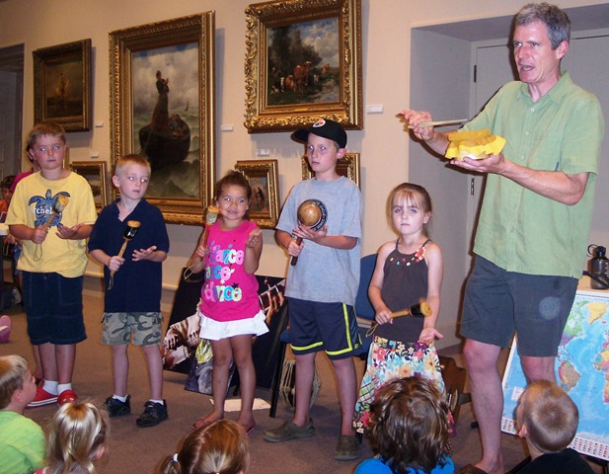

The United Arts Appeal
715 Falconer Street
Jamestown, New York 14701
716-484-7329

News Release
FOR IMMEDIATE RELEASE (July 31, 2012)

Photo caption: The United Arts Appeal recently received a grant from the Holmberg Foundation of Jamestown. In addition to providing operating support for eight major arts organizations in Chautauqua County, the United Arts Appeal also funds individual artists and smaller arts projects. One of these projects, pictured here, was a musical journey around the world presented last summer by Dave Ruch at Jamestown’s Prendergast Library.

United Arts Appeal Receives Holmberg Foundation Grant

Jamestown, NY – The United Arts Appeal of Chautauqua County has been awarded a grant from the Holmberg Foundation toward their 2012 Annual Fund Drive.

“We are so grateful for this support,” said UAA board member and grants coordinator Sally Ulrich. “Every dollar we raise helps strengthen the arts in Chautauqua County, making this a better place to live, work, and raise our families.”

In addition to funding for individual artists and smaller arts projects through its Projects Pool grants program, the United Arts Appeal provides operating support for eight of the larger arts organizations in Chautauqua County: the Chautauqua Regional Youth Ballet, Community Music Project, 1891 Fredonia Opera House, Infinity Visual and Performing Arts, Jamestown Concert Association, Lucille Ball Little Theatre of Jamestown, Reg Lenna Civic Center, and the Western New York Chamber Orchestra.

Mrs. Ulrich noted that individuals and organizations that would like to support the arts in Chautauqua County can send contributions by check to the United Arts Appeal, 715 Falconer Street, Jamestown, NY 14701.

For more information about the United Arts Appeal of Chautauqua County, including a full list of supporters, visit www.UnitedArtsAppeal.org.

###

