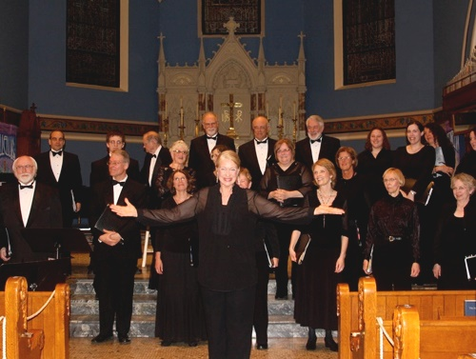

The United Arts Appeal
715 Falconer Street
Jamestown, New York 14701
716-484-7329

News Release
FOR IMMEDIATE RELEASE (August 6, 2013)

Photo caption: Concerts by the Chautauqua Chamber Singers are among the many programs offered by members of the United Arts Appeal of Chautauqua County. Contributors to the UAA’s 2013 Fund Drive by the end of the August will be acknowledged throughout the 2013-2014 season for their support of the arts.

Fund Drive Closing for United Arts Appeal

Jamestown, NY – The United Arts Appeal of Chautauqua County is closing its 2013 Fund Drive at the end of August, the last opportunity for contributors to be recognized during the 2013-2014 season.

“The eight member organizations of the United Arts Appeal show our appreciation by identifying our supporters in our printed programs throughout the year, on the UAA website, and more,” explained President Rick Davis. “Our fiscal year closes August 31, so we need to hear from our supporters by then in order to give them the full recognition they deserve.”

In addition to funding for individual artists and smaller arts projects through its Projects Pool Grants Program, the United Arts Appeal provides operating support for eight of the larger arts organizations in Chautauqua County: the Chautauqua Regional Youth Ballet, Community Music Project, 1891 Fredonia Opera House, Infinity Visual and Performing Arts, Jamestown Concert Association, Lucille Ball Little Theatre of Jamestown, Reg Lenna Civic Center, and the Western New York Chamber Orchestra.

Davis noted that the arts are an economic force, giving Chautauqua County a distinctive flavor and a competitive advantage in tourism, drawing in thousands of visitors each year, helping retain and attract business, and bringing significant resources from outside the county to local schools and institutions. The arts are also widely recognized as having a positive impact on the lives of children.

Chautauqua County, the Jessie Smith Darrah Fund, the Hultquist Foundation, and Lynn Development Group, LLC have made major contributions to the United Arts Appeal’s 2013 fund drive. Other significant contributors include Lyndon and Melanie Gritters, the Holmberg Foundation, Matric Limited, M. L. Feather, John and Margie Fuchs, Hope’s Windows, Inc., Dr. Bruce Rockwell, Wegmans, Carlson’s Jewelry Smithing, Clark Patterson Lee, Fessenden Laumer & DeAngelo, Family Health Medical Services, Mark and Donna Hampton, Betsy and David Shepherd, and Lissa and Sherwood VanDewark.

Contributions can be made by check to the United Arts Appeal, 715 Falconer Street, Jamestown, NY 14701.

For all the benefits available to contributors to the United Arts Appeal, see “Support UAA” at www.UnitedArtsAppeal.org. For the complete list of contributors, see “BRAVO!” at the website.

###

