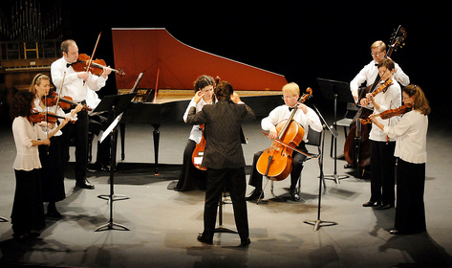

The United Arts Appeal
715 Falconer Street
Jamestown, New York 14701
716-484-7329

News Release
FOR IMMEDIATE RELEASE (August 8, 2012)

Photo caption: Last June’s Bach & Beyond Baroque Music Festival at the Fredonia Opera House is an example of programs offered by members of the United Arts Appeal of Chautauqua County. Those who contribute to the UAA’s 2012 Fund Drive by the end of the month will be acknowledged throughout the 2012-2013 season for their support of the arts. (Photo courtesy of the Dunkirk Observer)

United Arts Appeal Fund Drive Closing

Jamestown, NY – The end of August is the deadline for donors to the United Arts Appeal of Chautauqua County 2012 Fund Drive to be recognized during the 2012-2013 Season.

President Rick Davis explained that the eight member organizations of the United Arts Appeal show their appreciation to their supporters by identifying them in their printed programs throughout the year, on the UAA website, and more.

“Our fiscal year closes August 31,” Davis said, “so we need to hear from our supporters by then in order to give them the full recognition they deserve.”

In addition to funding for individual artists and smaller arts projects through its Projects Pool grants program, the United Arts Appeal provides operating support for eight of the larger arts organizations in Chautauqua County: the Chautauqua Regional Youth Ballet, Community Music Project, 1891 Fredonia Opera House, Infinity Visual and Performing Arts, Jamestown Concert Association, Lucille Ball Little Theatre of Jamestown, Reg Lenna Civic Center, and the Western New York Chamber Orchestra.

“The programs our members offer add considerably to the quality of life in Chautauqua County,” Davis noted. “This is an opportunity to make a difference in a big way!”

The United Arts Appeal receives significant support from Chautauqua County, the Jessie Smith Darrah Fund, the Hultquist Foundation, Community Development Association, and Dr. Bruce Rockwell. Major donors to the 2012 fund drive to date also include the Holmberg Foundation, Matric Limited, M. L. Feather, Phillips Lytle LLP, Wegmans, Carlson’s Jewelry, Fessenden Laumer & DeAngelo, Gebbie Foundation/Director's Discretionary Grant on behalf of Rhoe B. Henderson III, Mark and Donna Hampton, Lake Shore Savings Bank, Lakeshore Orthopedic Group, Betsy and David Shepherd, Short & Smith Insurance Associates, Carolyn and Tyler Swanson, and Lissa and Sherwood VanDewark.

Contributions can be made by check to the United Arts Appeal, 715 Falconer Street, Jamestown, NY 14701.

For all the benefits available to contributors to the United Arts Appeal, see “Support UAA” at www.UnitedArtsAppeal.org. For the complete list of contributors, see “BRAVO!” at the website.

###

