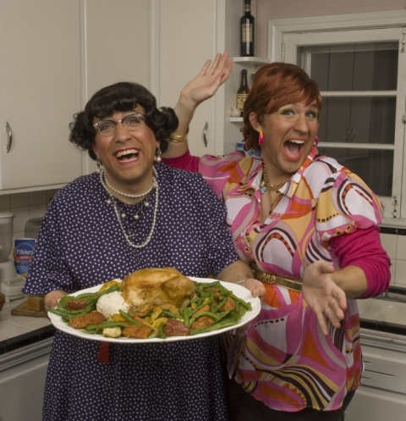

The United Arts Appeal
715 Falconer Street
Jamestown, New York 14701
716-484-7329

August 17, 2011
FOR IMMEDIATE RELEASE

Photo caption: Unique entertainment like the Fredonia Opera House’s Friday, August 19, presentation of “Cooking with the Calamari Sisters…MANGIA ITALIANO!” is an example of programs offered by members of the United Arts Appeal of Chautauqua County. Those who contribute to the UAA’s 2011 Fund Drive by the end of the month will be acknowledged throughout the 2011-2012 season for their support of the arts.

UNITED ARTS APPEAL FUND DRIVE CLOSING

Jamestown, NY – The deadline is fast approaching for the United Arts Appeal of Chautauqua County to recognize its 2011 Fund Drive donors throughout the 2011-2012 season.

Treasurer Sally Ulrich explained that the eight member organizations of the United Arts Appeal show their appreciation to their supporters by identifying them in their printed programs throughout the year, on the UAA website, and more.

“Our fiscal year closes August 31,” Mrs. Ulrich said, “so we need to hear from our supporters by then in order to give them the full recognition they deserve.”

In addition to funding for individual artists and smaller arts projects through its Projects Pool grants program, the United Arts Appeal provides operating support for eight of the larger arts organizations in Chautauqua County: the Chautauqua Regional Youth Ballet, Community Music Project, 1891 Fredonia Opera House, Infinity Visual and Performing Arts, Jamestown Concert Association, Lucille Ball Little Theatre of Jamestown, Reg Lenna Civic Center, and the Western New York Chamber Orchestra.

“The programs our members offer add significantly to the quality of life in Chautauqua County,” Mrs. Ulrich added. “This is an opportunity to make a difference in a big way!”

The United Arts Appeal receives significant support from Chautauqua County, the Jessie Smith Darrah Fund, and the Hultquist Foundation. Major donors to the 2011 fund drive to date include Community Development Association, Matric Limited, M. L. Feather, KeyBank, Phillips Lytle LLP, Dr. Bruce Rockwell, Wegmans, Carlson’s Jewelry, Fessenden Laumer & DeAngelo, Gebbie Foundation/Director's Discretionary Grant on behalf of Rhoe B. Henderson III, Mark and Donna Hampton, Jamestown Area Medical Associates LLP, Lake Shore Savings Bank, Betsy and David Shepherd, Short & Smith Insurance Associates, Tyler Swanson and Carolyn French, and Lissa and Sherwood VanDewark.

Contributions can be made by check to the United Arts Appeal, 715 Falconer Street, Jamestown, NY 14701.

For all the benefits available to contributors to the United Arts Appeal, see “Support UAA” at www.UnitedArtsAppeal.org. For the complete list of contributors, see “BRAVO!” at the website.

###

