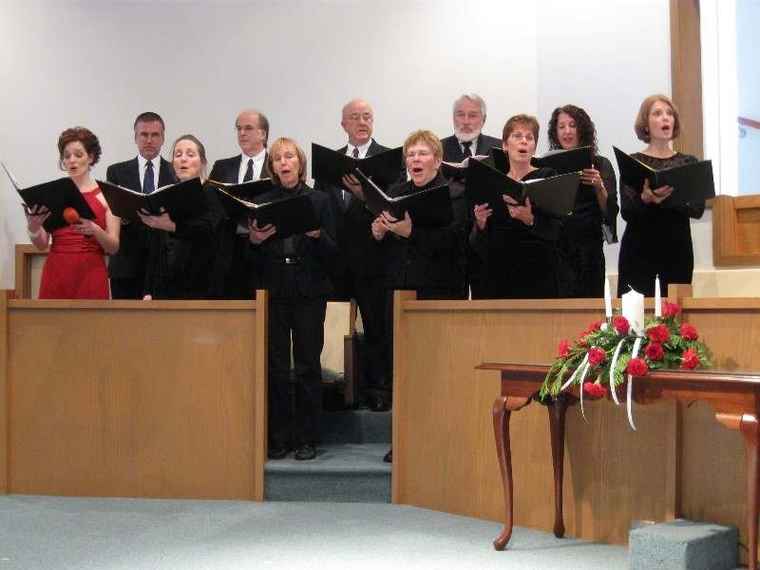

The United Arts Appeal
715 Falconer Street
Jamestown, New York 14701
716-484-7329

August 11, 2010
FOR IMMEDIATE RELEASE

Photo caption: The Chautauqua Chamber Singers of Community Music Project is one of many performing groups supported by the United Arts Appeal of Chautauqua County. Those who contribute by August 31 to the UAA’s 2010 Fund Drive will be acknowledged throughout the 2010-2011 season for their support of the arts.

UNITED ARTS APPEAL COMPLETING FUND DRIVE

Jamestown, NY –With the closing of its fiscal year on August 31, the United Arts Appeal of Chautauqua County is offering one last opportunity for contributors to be recognized throughout the 2010-2011 season.

“Support for the arts in Chautauqua County is truly wonderful,” noted UAA treasurer Sally Ulrich. “Our children have an amazing range of learning and performing opportunities, and our residents and visitors can enjoy top quality local and even international professional performances and exhibits. Whether your passion is great movies, live theatre, fine music, graceful dance, or simply making Chautauqua County the finest it can be for yourself and your family, you help further that passion by supporting the arts.”

In addition to funding for individual artists and smaller arts projects through its Projects Pool, the United Arts Appeal provides operating support for eight of the larger arts organizations in Chautauqua County. These are the Chautauqua Regional Youth Ballet, Community Music Project, 1891 Fredonia Opera House, Infinity Performing Arts Program, Jamestown Concert Association, Lucille Ball Little Theatre of Jamestown, Reg Lenna Civic Center, and the Western New York Chamber Orchestra.

Ms. Ulrich pointed out that the eight member organizations of the United Arts Appeal show their appreciation to their supporters by recognizing them in their printed programs throughout the year, on the UAA website, and more. To guarantee this recognition, contributions must be received by August 31.

Contributions can be made by check to the United Arts Appeal, 715 Falconer Street, Jamestown, NY 14701.

The United Arts Appeal receives major support from Chautauqua County, the Jessie Smith Darrah Fund, and the Hultquist Foundation. Patrons (contributors of $1,000+) to date for the 2010 Fund Drive include Lyndon and Melanie Gritters, Matric Limited, and Bruce Rockwell. Phillips Lytle LLP and Wegmans made Special Gifts ($500+), and Donors ($250+) include Carlsons Jewelry, Jamestown Area Medical Associates LLP, Lake Shore Savings Bank, Betsy and David Shepherd, Short & Smith Insurance Associates, Tyler Swanson, Lissa and Sherwood VanDewark, and the Gebbie Foundation/Director’s Discretionary Grant on behalf of Rhoe Henderson.

For all the benefits available to contributors to the United Arts Appeal, see “Support UAA” at www.UnitedArtsAppeal.org. For the complete list of contributors, see “BRAVO!” at the website.

###

