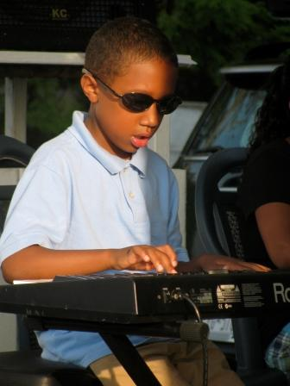

The United Arts Appeal
715 Falconer Street
Jamestown, New York 14701
716-484-7329

June 17, 2011
FOR IMMEDIATE RELEASE

Photo caption: Infinity Visual and Performing Arts is one of the organizations supported by the United Arts Appeal of Chautauqua County. Those who contribute to the UAA’s 2011 Fund Drive will be acknowledged throughout the 2011-2012 season for their support of the arts. Pictured here is one of the young people served by Infinity, which is dedicated to building the resiliency of our community’s youth by providing unique opportunities through access to the arts.

UNITED ARTS APPEAL FUND DRIVE DRAWING TO CLOSE

Jamestown, NY – “Not everyone realizes how important the arts are as an economic force in our community,” said Rick Davis, president of the United Arts Appeal of Chautauqua County.

In announcing that the UAA is wrapping up its 2011 fund drive, Davis stated, “The arts give Chautauqua County a distinctive flavor and a competitive advantage in tourism, bringing in thousands of visitors each year, helping retain and attract business, and bringing significant resources from outside the county to our schools and institutions.” He also noted that experiencing the arts can change kids’ lives forever.

In addition to funding for individual artists and smaller arts projects through its Projects Pool grants program, the United Arts Appeal provides operating support for eight of the larger arts organizations in Chautauqua County. These are the Chautauqua Regional Youth Ballet, Community Music Project, 1891 Fredonia Opera House, Infinity Visual and Performing Arts, Jamestown Concert Association, Lucille Ball Little Theatre of Jamestown, Reg Lenna Civic Center, and the Western New York Chamber Orchestra.

The eight member organizations of the United Arts Appeal show their appreciation to their supporters by recognizing them in their printed programs throughout the year, on the UAA website, and more.

Contributions can be made by check to the United Arts Appeal, 715 Falconer Street, Jamestown, NY 14701.

The United Arts Appeal receives signficant support from Chautauqua County, the Jessie Smith Darrah Fund, and the Hultquist Foundation. Major donors to the 2011 fund drive include Matric Limited, M. L. Feather, KeyBank, Phillips Lytle LLP, Dr. Bruce Rockwell, Wegmans, Carlson’s Jewelry, Fessenden Laumer & DeAngelo, Gebbie Foundation/Director's Discretionary Grant on behalf of Rhoe B. Henderson III, Mark and Donna Hampton, Jamestown Area Medical Associates LLP, Lake Shore Savings Bank, Betsy and David Shepherd, Short & Smith Insurance Associates, Tyler Swanson and Carolyn French, and Lissa and Sherwood VanDewark.

For all the benefits available to contributors to the United Arts Appeal, see “Support UAA” at www.UnitedArtsAppeal.org. For the complete list of contributors, see “BRAVO!” at the website.

###

