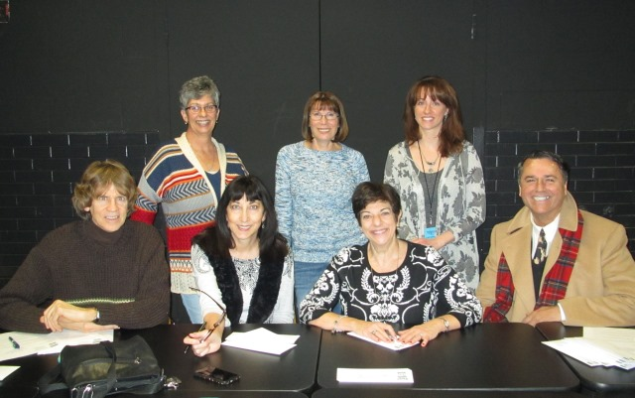

The United Arts Appeal
715 Falconer Street
Jamestown, New York 14701
716-484-7329

News Release
FOR IMMEDIATE RELEASE (January 16, 2015)

Photo caption: At their January meeting United Arts Appeal of Chautauqua County board members sent letters to local businesses and selected individuals, requesting their support for the arts in 2015. Members participating were (from left, seated) Jack Hemink, Elizabeth Bush, Nina Karbacka, Bob Ostrom, (standing) Lynn Warner, Lissa VanDewark, and Shane Hawkins.

United Arts Appeal Launches 2015 Fund Drive

Jamestown, NY – For more than 25 years, the United Arts Appeal of Chautauqua County (UAA) has been providing funding for local arts organizations. that present hundreds of concerts, performances, classes and exhibits enjoyed by thousands of people each year.

At their January meeting UAA board members sent their annual fund raising letter, primarily to businesses, asking for support for their member organizations and the smaller groups and independent artists that receive UAA Projects Pool grants.

“A healthy arts community has a significant impact on the local economy, so our focus is on soliciting businesses,” said President Lynn Warner. “We also deeply appreciate the support of the County, local foundations and individuals, as well.”

As a group, this is the only request the United Arts Appeal makes of the local community.

United Arts Appeal member organizations include the Chautauqua Regional Youth Ballet, Community Music Project, 1891 Fredonia Opera House, Infinity Visual & Performing Arts, Jamestown Concert Association, Lucille Ball Little Theatre of Jamestown, Reg Lenna Center for The Arts, and Western New York Chamber Orchestra.

Contributions to the United Arts Appeal are tax deductible, and contributors are offered a range of benefits for their generosity. These benefits include free admissions to selected performances and recognition in printed programs and on the UAA’s website. Details are on the Support UAA page at UnitedArtsAppeal.org.

In 2014 the United Arts Appeal received major support from Chautauqua County, the Jessie Smith Darrah Fund, and the Hultquist Foundation.

Community Development Association was a Benefactor for the 2014 Fund Drive. Patrons were Lyndon and Melanie Gritters, the Holmberg Foundation, Matric Limited, and Bruce Rockwell. Special Gifts were received from M.L. Feather, John and Margie Fuchs, Hope’s Windows, and Wegmans. Donors included Artone LCC, Family Health Medical Services, Fessenden Laumer & DeAngelo, Mark and Donna Hampton, David and Betsy Shepherd, Short & Smith Insurance Assoc., Carolyn and Tyler Swanson, and Sherwood and Lissa VanDewark.

Businesses and individuals that want to help fund the arts in Chautauqua County can send their contributions to the United Arts Appeal, 715 Falconer Street, Jamestown, NY 14701.

For more information, visit www.UnitedArtsAppeal.org or the United Arts Appeal page on Facebook.

###

