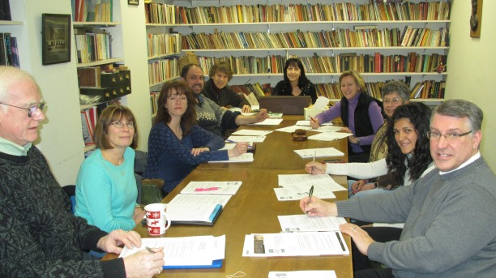

The United Arts Appeal
715 Falconer Street
Jamestown, New York 14701
716-484-7329

News Release
FOR IMMEDIATE RELEASE (February 6, 2014)

Photo caption: The board of the United Arts Appeal of Chautauqua County recently sent out fund raising letters that included information on Kaleidoscope, a sampling of the offerings of the eight UAA member organizations. Kaleidoscope will be presented on Sunday afternoons, March 2 at the Lucille Ball Little Theatre of Jamestown and March 9 at the Fredonia Opera House. Pictured (from left) are Jim Ewing, Lissa VanDewark, Shane Hawkins, Adam Owens, Jack Hemink, Elizabeth Bush, Sally Ulrich, Lynn Warner, Amanda Conte, and Rick Davis.

United Arts Appeal Fund Drive Underway

Jamestown, NY – For more than 25 years, the United Arts Appeal of Chautauqua County (UAA) has supported arts organizations that present nearly 2,000 concerts, performances, classes and exhibits each year.

At their most recent meeting United Arts Appeal of Chautauqua County board members sent out their annual fund raising letter, primarily to businesses, asking for support for UAA members and the smaller groups and independent artists that receive UAA funding.

“The arts have such a positive economic impact on our community that many businesses as well as individuals are happy to support the United Arts Appeal,” said President Rick Davis. “In return, we give them significant recognition for their support.”

Davis said the letters included an invitation to Kaleidoscope, a sampling of the offerings of the eight UAA member organizations that will be presented at 2 p.m. on March 2 in Jamestown and March 9 in Fredonia.

“We first presented Kaleidoscope two years ago to give the entire community the opportunity to see the great arts programming in Chautauqua County,” Davis noted. “Both Sunday afternoons will feature folk music, singer/songwriters, ballet, theater, chamber players and singers, and more.”

All eight UAA member organizations -- Chautauqua Regional Youth Ballet, Community Music Project, 1891 Fredonia Opera House, Infinity Visual & Performing Arts, Jamestown Concert Association, Lucille Ball Little Theatre of Jamestown, Reg Lenna Center for the Arts, and Western New York Chamber Orchestra -- will contribute to the performances.

Admission for either event is just $10. Tickets for Sunday, March 2, in Jamestown can be purchased at the Lucille Ball Little Theatre and by calling (716) 483-1095. Tickets for Sunday, March 9, in Fredonia can be purchased at the 1891 Fredonia Opera House or reserved by calling (716) 679-1891. Tickets will also be available at the door.

Contributions to the United Arts Appeal are tax deductible, and contributors are offered a range of benefits for their generosity, including free admissions to selected performances and recognition in printed programs and on the UAA’s website. Details are on the Support UAA page at UnitedArtsAppeal.org.

Businesses and individual that would like to support the arts in Chautauqua County are invited to send their contributions to the United Arts Appeal, 715 Falconer Street, Jamestown, NY 14701. Responses received by February 21 will receive a pair of tickets to Kaleidoscope.

In 2013 the United Arts Appeal received major support from Chautauqua County, the Jessie Smith Darrah Fund, and the Hultquist Foundation.

Lynn Development Group, LLC was a Benefactor for the 2013 Fund Drive. Patrons were Lyndon and Melanie Gritters, the Holmberg Foundation, and Matric Limited. Special Gifts were received from M.L. Feather, John and Margie Fuchs, Hope’s Windows, Dr. Bruce Rockwell, and Wegmans. Donors included Carlson’s Jewelry Smithing, Clark Patterson Lee, Family Health Medical Services, Fessenden Laumer & DeAngelo, Mark and Donna Hampton, Betsy and David Shepherd, and Lissa and Sherwood VanDewark.

For more information, visit UnitedArtsAppeal.org and the United Arts Appeal page on Facebook.

###

