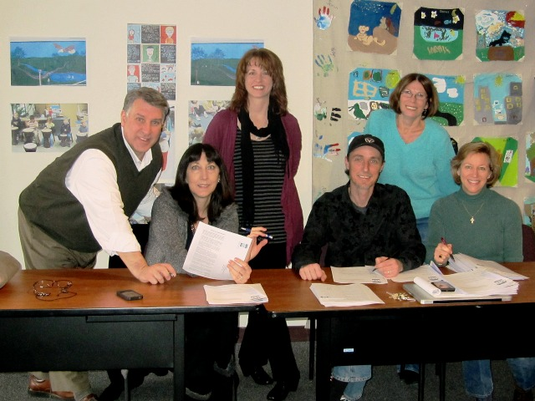

The United Arts Appeal
715 Falconer Street
Jamestown, New York 14701
716-484-7329

News Release
FOR IMMEDIATE RELEASE (January 16, 2013)

Photo caption: At their January meeting, United Arts Appeal of Chautauqua County board members (from left) Rick Davis, Elizabeth Bush, Shane Hawkins, Jeff Erickson, Lissa VanDewark and Sally Ulrich sent letters to local businesses and selected individuals, requesting their support for the arts in 2013.

United Arts Appeal Launches 2013 Fund Drive

Jamestown, NY – The United Arts Appeal of Chautauqua County is calling on the community to sustain a wealth of local arts organizations.

UAA board members recently sent letters to businesses and selected individuals throughout the county, asking for support in 2013 for their eight member organizations and the smaller groups and independent artists that receive UAA Projects Pool funding. The Chautauqua Regional Youth Ballet, Community Music Project, 1891 Fredonia Opera House, Infinity Visual & Performing Arts, Jamestown Concert Association, Lucille Ball Little Theatre of Jamestown, Reg Lenna Civic Center, and the Western New York Chamber Orchestra are the member organizations of the United Arts Appeal.

“With the significant impact that a healthy arts community has on the local economy, our focus is on soliciting businesses,” said Rick Davis, president of the United Arts Appeal board. “We are also greatly indebted to the support of the county, local foundations and individuals, as well.”

As a group, this is the only request the United Arts Appeal makes of the local community.

Davis cited Robert L. Lynch, President and CEO of Americans for the Arts, in his observation that, “Nonprofit arts and culture organizations are rooted locally…. employing people in jobs that cannot be shipped overseas and purchasing goods and services within the community. What’s more, spending by these organizations directly supports other locally-based businesses not typically associated with the arts—an array of occupations that span multiple industries.”

In 2012 the United Arts Appeal received major support from Chautauqua County, the Jessie Smith Darrah Fund, the Chautauqua Region Community Foundation, and the Hultquist Foundation.

Benefactors (contributors of $2,500) for the 2012 Fund Drive were Community Development Assoc. LLC and Dr. Bruce Rockwell. Patrons ($1,000 contributors) were the Holmberg Foundation and Matric Limited. Special Gifts ($500) were received from M.L. Feather, John and Margie Fuchs, Phillips Lytle LLP, and Wegmans. Donors ($250) included Carlson’s Jewelry, Fessenden Laumer & DeAngelo, Mark and Donna Hampton, Lake Shore Savings Bank, Lakeshore Orthopedic Group, Betsy and David Shepherd, Short & Smith Insurance, Carolyn and Tyler Swanson, Lissa and Sherwood VanDewark, and the Gebbie Foundation/Director’s Discretionary Grant on behalf of Rhoe Henderson.

Contributors to the United Arts Appeal are offered a range of benefits for their generosity, including recognition in printed programs and on the UAA’s website and free admissions to selected performances. Details are on the Support UAA page at UnitedArtsAppeal.org.

Any business or individual that would like to support the arts in Chautauqua County is invited to send their contribution to the United Arts Appeal, 715 Falconer Street, Jamestown, NY 14701.

For more information on the United Arts Appeal of Chautauqua County, visit http://unitedartsappeal.org/.

For information on performances offered by member organizations, visit the United Arts Appeal page on Facebook.

###

