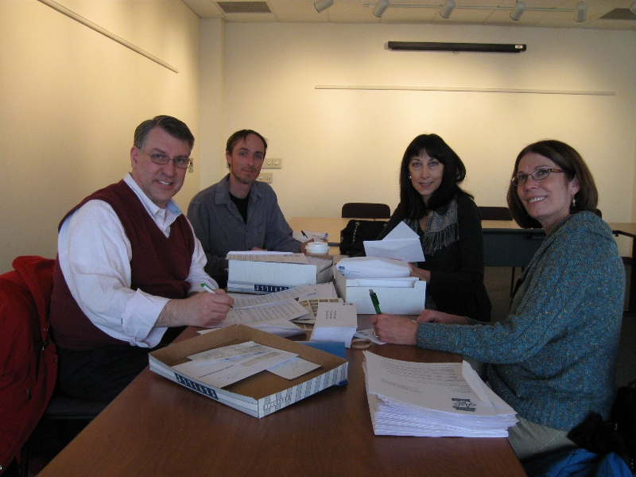

The United Arts Appeal
715 Falconer Street
Jamestown, New York 14701
716-484-7329

February 8, 2011
FOR IMMEDIATE RELEASE

Photo caption: At their recent meeting, United Arts Appeal of Chautauqua County board members Rick Davis, Jeff Erickson, Elizabeth Bush and Lissa VanDewark sent letters to local businesses and selected individuals, requesting their support for the arts in 2011.

UNITED ARTS APPEAL LAUNCHES 2011 FUND DRIVE

Jamestown, NY – The United Arts Appeal of Chautauqua County is again asking the community to step up to support a wealth of local arts organizations.

UAA board members recently sent letters to businesses and selected individuals throughout the county, asking for their support in 2011 for their eight member organizations and the many smaller groups and independent artists that receive UAA funding. The Chautauqua Regional Youth Ballet, Community Music Project, 1891 Fredonia Opera House, Infinity Visual & Performing Arts, Jamestown Concert Association, Lucille Ball Little Theatre of Jamestown, Reg Lenna Civic Center, and the Western New York Chamber Orchestra are the member organizations of the United Arts Appeal.

“In part because of the strong impact that a healthy arts community has on the local economy, our focus is on soliciting businesses,” said Rick Davis, president of the United Arts Appeal board. “We are also greatly indebted to the support of the county, local foundations and individuals, as well.”

Davis cited David Rockefeller’s findings when he established the Business Committee for the Arts Inc., noting that the arts are essential to the quality of life in a community. Rockefeller found that the arts enhance economic vitality and are essential to the development of a skilled and creative workforce. At the same time, they increase SAT scores, improve academic performance and problem-solving skills, and help redirect at-risk students.

“As a group, this is the only request we make of the local community,” Davis added. “This support is critical to maintaining the strength of the arts in Chautauqua County.”

In 2010 the United Arts Appeal received major support from Chautauqua County, the Jessie Smith Darrah Fund, and the Hultquist Foundation. Patrons (contributors of $1,000+) for the 2010 Fund Drive included Lyndon and Melanie Gritters, Matric Limited, Bruce Rockwell, and the Reg and Betty Lenna Fund. Phillips Lytle LLP and Wegmans made Special Gifts ($500+), and Donors ($250+) included Carlsons Jewelry, Mark and Donna Hampton, Jamestown Area Medical Associates LLP, Lake Shore Savings Bank, Betsy and David Shepherd, Short & Smith Insurance Associates, Tyler Swanson, Lissa and Sherwood VanDewark, and the Gebbie Foundation/Director’s Discretionary Grant on behalf of Rhoe Henderson.

Contributors to the United Arts Appeal are offered a range of benefits for their generosity, including recognition in printed programs and free admissions to selected performances.

Any business or individual that did not receive a request for support is invited to call (716) 484-7329 and ask for materials.

For information on performances offered by member organizations, visit the United Arts Appeal page on Facebook.
###

