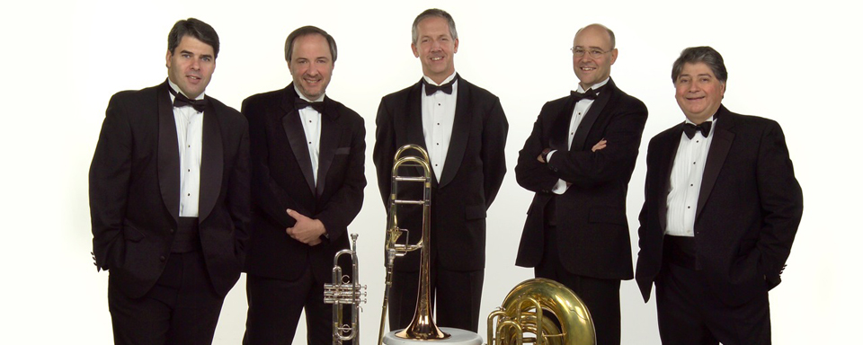

The United Arts Appeal
715 Falconer Street
Jamestown, New York 14701
716-484-7329

News Release
FOR IMMEDIATE RELEASE (October 4, 2012)

Photo caption: The United Arts Appeal (UAA) recently received a major grant from the Chautauqua Region Community Foundation. The UAA supports eight major arts organizations in Chautauqua County, including the Jamestown Concert Association. The Concert Association is presenting the Philadelphia Brass Quintet, pictured here, at 8 p.m. on Friday, October 12, in St. Luke’s Episcopal Church in downtown Jamestown.

United Arts Appeal Receives Community Foundation Grant

Jamestown, NY – The United Arts Appeal of Chautauqua County recently received a major grant for operational support from the Chautauqua Region Community Foundation.

“We are thrilled with this support from the Community Foundation,” said UAA board member and grants coordinator Sally Ulrich. “It is especially meaningful to us as it comes from the Foundation’s Reg and Betty Lenna Fund.”

Ms. Ulrich explained that for many years the United Arts Appeal received support from the Lennas through their Fund. With their passing, the Fund is now administered by the Foundation. “We would like to think,” she added, “that Reg and Betty would be happy to know how much they are continuing to support the arts that were so important to them in the community to which they gave so generously.”

In addition to funding for individual artists and smaller arts projects through its Projects Pool grants program, the United Arts Appeal provides operating support for eight of the larger arts organizations in Chautauqua County: the Chautauqua Regional Youth Ballet, Community Music Project, 1891 Fredonia Opera House, Infinity Visual and Performing Arts, Jamestown Concert Association, Lucille Ball Little Theatre of Jamestown, Reg Lenna Civic Center, and the Western New York Chamber Orchestra.

For more information about the United Arts Appeal of Chautauqua County, including a full list of supporters, visit www.UnitedArtsAppeal.org.

###

