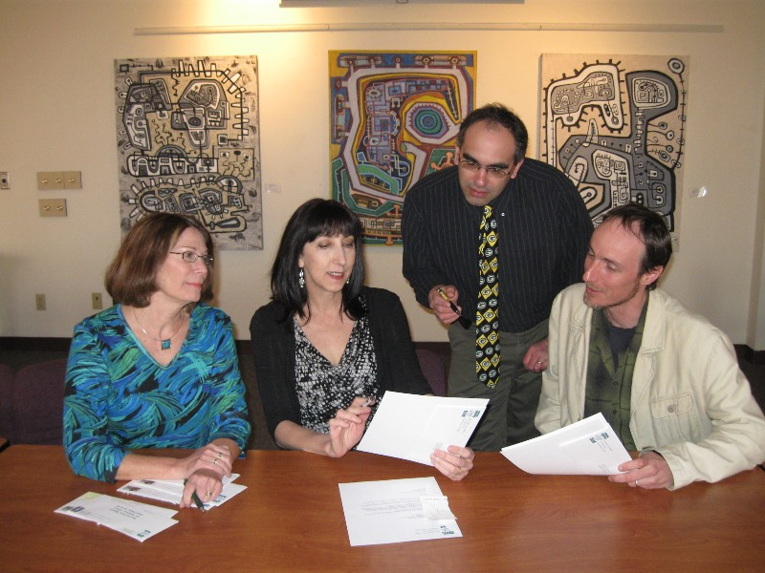
The United Arts Appeal
715 Falconer Street
Jamestown, New York 14701
716-484-7329

March 23, 2010
FOR IMMEDIATE RELEASE

Photo caption: At their recent meeting, United Arts Appeal of Chautauqua County board members Lissa VanDewark, Elizabeth Bush, Dan Pierce, and Jeff Erickson sent letters to local businesses requesting their support for the arts in 2010. Also participating but not pictured were Rick Davis, Jay East, Shane Hawkins, Jack Hemick, and Sally Ulrich.

UNITED ARTS APPEAL SEEKING SUPPORT OF LOCAL BUSINESSES

Jamestown, NY – The United Arts Appeal of Chautauqua County is again asking businesses to step up to support a wealth of local arts organizations.

“Area businesses recognize the importance of the arts to the health of our community, the well-being of their employees, and ultimately their own success,” said Rick Davis, president of the United Arts Appeal. “Even though these are challenging economic times, we anticipate that they will do all they can to keep the arts alive in Chautauqua County.”

This week UAA board members sent letters to businesses throughout the county, asking for their support in 2010 for their eight member organizations and the many smaller groups and independent artists that receive UAA funding. The Chautauqua Regional Youth Ballet, Community Music Project, 1891 Fredonia Opera House, Infinity Performing Arts Program, Jamestown Concert Association, Lucille Ball Little Theatre of Jamestown, Reg Lenna Civic Center, and the Western New York Chamber Orchestra are the large arts organizations members of the United Arts Appeal.

Davis noted that with the increasing competitiveness of communities to attract and retain businesses as well as residents and visitors, now more than ever a strong arts environment is a necessity, not a luxury.

“As a group, this is the only request we make of local businesses,” the UAA president added. “Their support is critical to maintaining the strength of the arts locally.”

Contributors to the United Arts Appeal are offered a range of benefits for their generosity, including recognition in printed programs and free admissions to selected performances.

Any business that does not receive a request for support is invited to call (716) 484-7329 and ask for information.

###

